**Laporan Hasil Praktikum HTML, CSS, dan JavaScript**



Nama :

Gina Nur Safa

XII MULTIMEDIA

**SMK NEGERI 50 JAKARTA**

Jl. Cipinang Muara I Jatinegara Jakarta Timur 13240 Tlp/Fax : 021-8194466

Website : [www.smk50jkt.sch.id](http://www.smk50jkt.sch.id) – Email: [smk_limapuluh@yahoo.com](mailto:smk_limapuluh@yahoo.com)

1. **Tema Website**

Tema dari website saya adalah Ilustrasi yang bernama DIPPIES disitu saya menjual ilustrasi dengan banyak jenis.

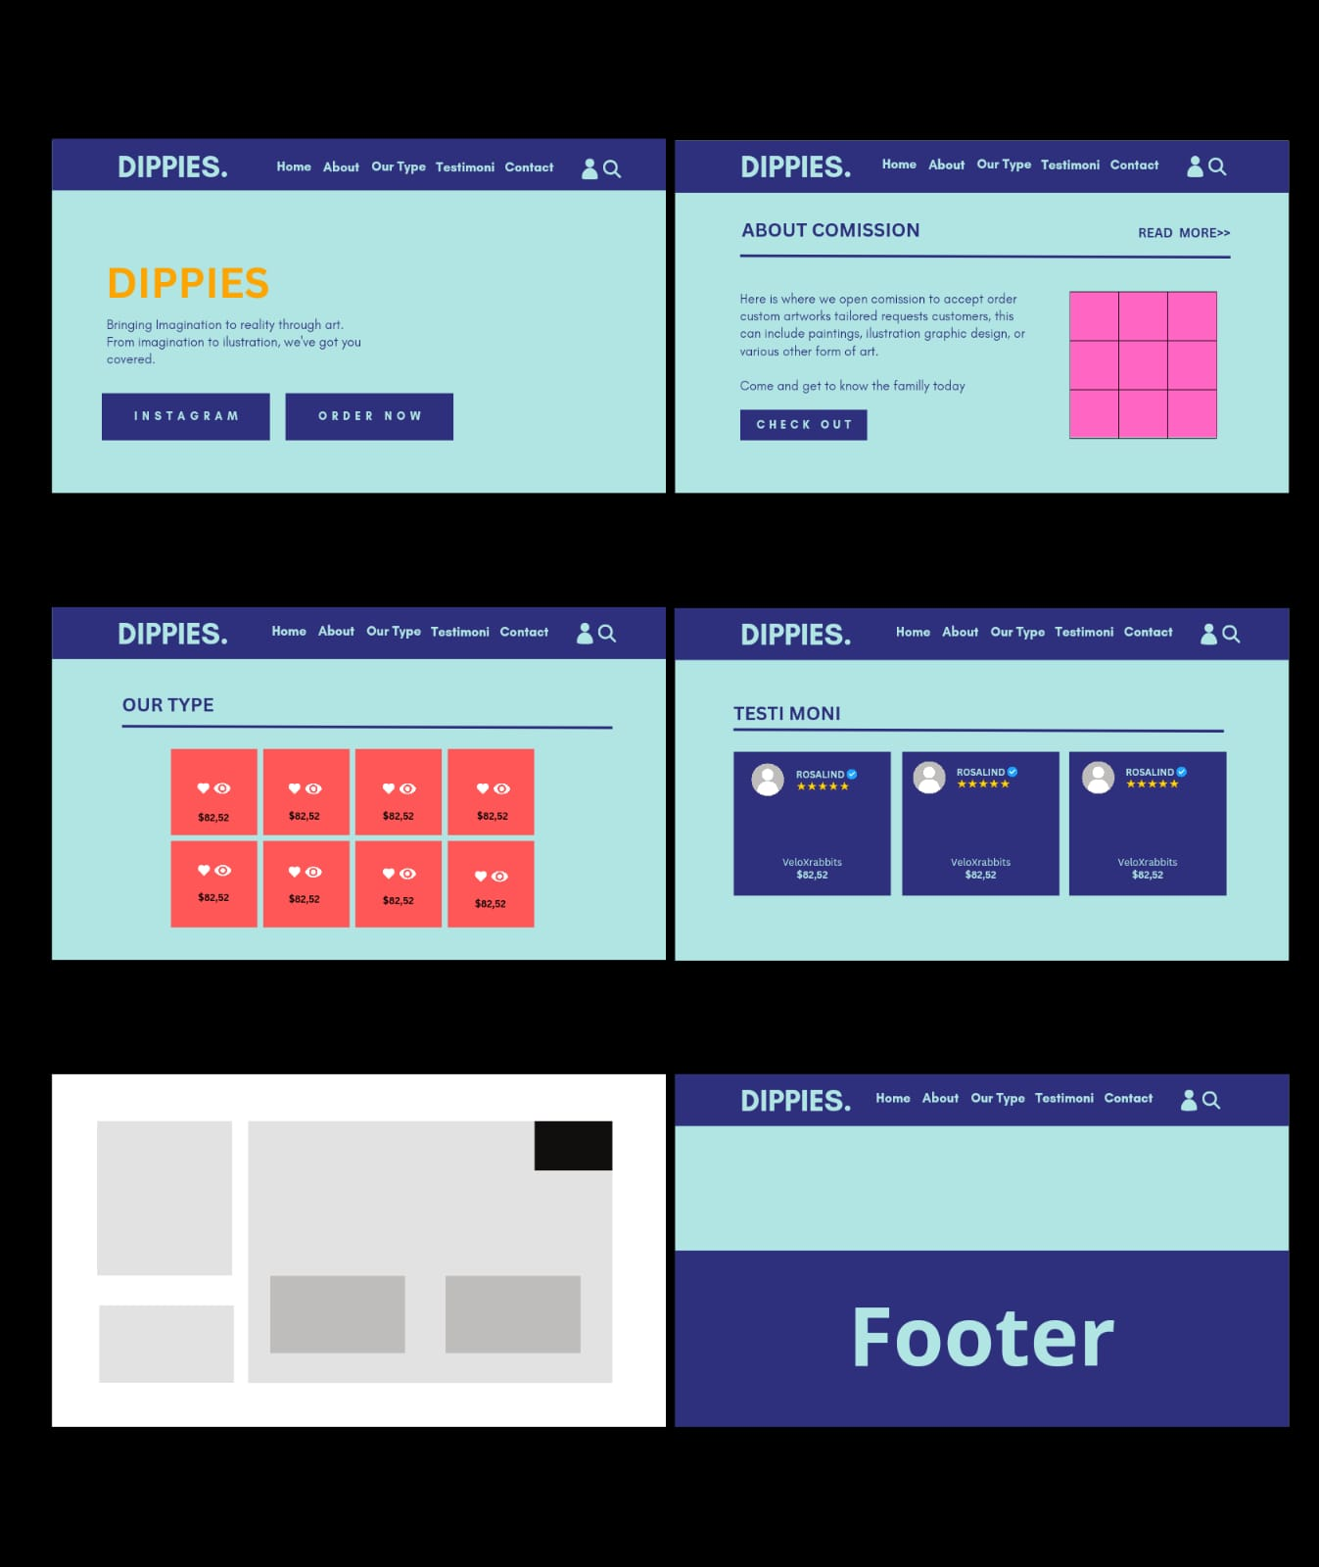**Berikut Storyboardnya:**

1. **Source code index**

* **Home & Header index.html**
* <!DOCTYPE html>
* <html lang="en">
* <head>
* <meta charset="UTF-8">
* <meta http-equiv="X-UA-Compatible" content="IE=edge">
* <meta name="viewport" content="width=device-width, initial-scale=1.0">
* <title>Ilustration</title>
* <link
* rel="stylesheet"
* href="https://unpkg.com/swiper@8/swiper-bundle.min.css"
* />
* <link rel="stylesheet" href="https://cdnjs.cloudflare.com/ajax/libs/font-awesome/6.1.0/css/all.min.css">
* <link rel="stylesheet" href="style.css">
* </head>
* <body>
* <header class="header">
* <a href="#" class="logo"> <i class="fas fa-cubes"></i> Dippies. </a>
* <nav class="navbar">
* <a href="#home">Home</a>
* <a href="#about">About</a>
* <a href="#ourtype">ourtype</a>
* <a href="#Testimoni">Testimoni</a>
* <a href="#Contact">Contact</a>
* </nav>
* <div class="icons">
* <div id="menu-btn" class="fas fa-bars"></div>
* <a href="index profile.html"><div id="login-btn" class="fas fa-user"></div></a>
* <a href="main search.js"><div id="search-btn" class="fas fa-search"></div></a>
* </div>
* </header>
* <section class="home" id="home">
* <div class="slides-container">
* <div class="slide active">
* <div class="content">
* <div class="slideimg">
* <img decoding="async" src="img/main.png">
* </div>
* <h3>Bringing Imagination to Reality Through Art.
* From Imagination to Illustration, We've Got You Covered.</h3>
* <a href="https://instagram.com/__wtfzx?igshid=ZW9memh2M2l4a2l3" class="btn">instagram</a>
* <a href="https://wa.me/c/6288902028471" class="btn">order now</a>
* </div>
* <div class="img">
* <img decoding="async" src="img/icon2.png" alt="">
* </div>
* </div>
* <div class="slide">
* <div class="content">
* <div class="slideimg">
* <img decoding="async" src="img/main.png">
* </div>
* <h3>Bringing Imagination to Reality Through Art.
* From Imagination to Illustration, We've Got You Covered.</h3>
* <a href="https://instagram.com/__wtfzx?igshid=ZW9memh2M2l4a2l3" class="btn">Instagram</a>
* <a href="https://wa.me/c/6288902028471" class="btn">order now</a>
* </div>
* <div class="img">
* <img decoding="async" src="img/icon.png" alt="">
* </div>
* </div>
* </div>
* <div id="next-slide"class="fas fa-angle-right" onclick="next()"></div>
* <div id="prev-slide"class="fas fa-angle-left" onclick="next()"></div>
* </section>
* **Screenshoot Home & Header index.html**

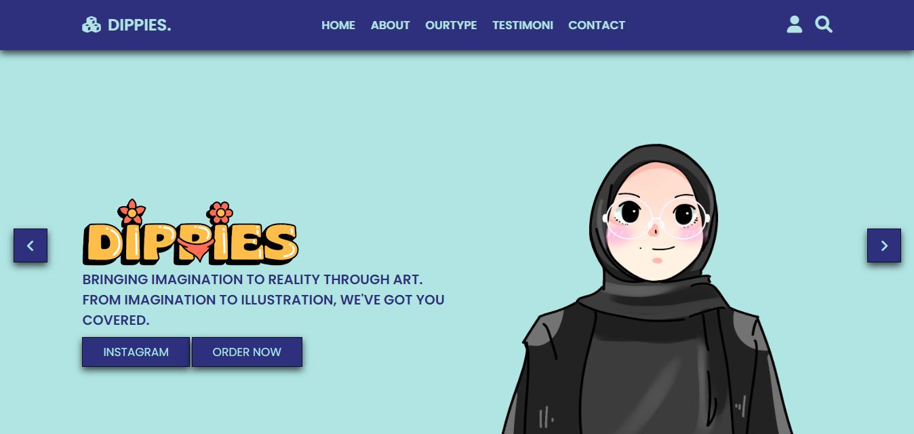

* **About Comission about.html**

<section class="about" id="about"></section>

<section class="about" id="about comission"></section>

<section>

<h1 class="title"> About <span>Comission</span> <a href="https://sites.google.com/u/2/d/186j39-JYwBnHUfuQfrussZ5nL4IiWspp/preview">read more >></a> </h1>

</section>

<section class="firepit">

    <div class="content">

        <h3>Comission</h3>

        <p>Here is where we open comission to accept order custom artworks

            tailored requests customers. This can include paintings, ilustrations

            graphic design, or various other form of art.<br><br>

            Come and get to know the family today; showcase

            your skills and find like minded people.

        </p>

        <a href="#" class="btn">check out</a>

    </div>

    <div class="video-container">

        <video width="500px" height="500px" controls="controls">

            <source src="img/about comission.mp4" type="video/mp4" />

           </video>

    </div>

</section>

* **Screenshoot about.html**

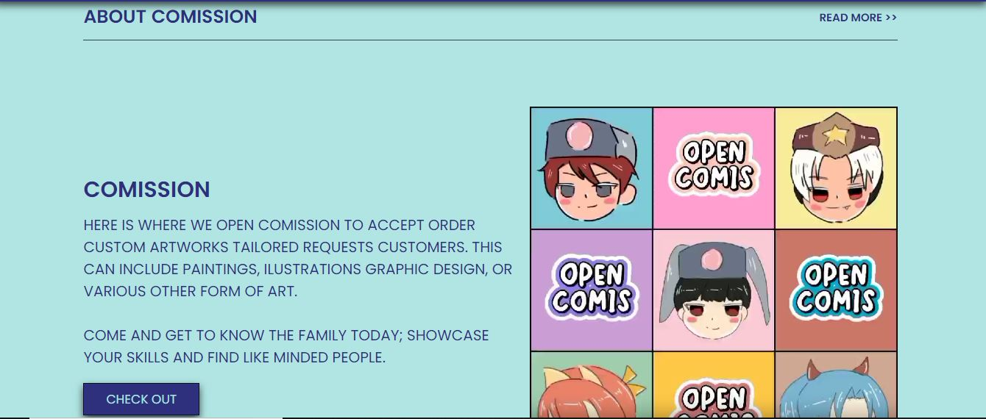

* **Ourtype.html**

<section class="ourtype" id="ourtype">

    <h1 class="title"> our <span>type</span><a href="#">view all >></a> </h1>

    <div class="box-container">

        <div class="box">

            <div class="icons">

                <a href="#" class="fas fa-heart"></a>

                <a href="#" class="fas fa-eye"></a>

            </div>

            <div class="img">

                <img decoding="async" src="img/katalog1.png">

            </div>

            <div class="content">

                <h3>Cartoon</h3>

                <div class="price">$10.00</div>

                <div class="stars">

                    <i class="fa fa-star"></i>

                    <i class="fa fa-star"></i>

                    <i class="fa fa-star"></i>

                    <i class="fa fa-star"></i>

                    <i class="fa fa-star"></i>

                </div>

            </div>

        </div>

        <div class="box">

            <div class="icons">

                <a href="#" class="fas fa-heart"></a>

                <a href="#" class="fas fa-eye"></a>

            </div>

            <div class="img">

                <img decoding="async" src="img/katalog2.png">

            </div>

            <div class="content">

                <h3>Cartoon</h3>

                <div class="price">$10.00</div>

                <div class="stars">

                    <i class="fa fa-star"></i>

                    <i class="fa fa-star"></i>

                    <i class="fa fa-star"></i>

                    <i class="fa fa-star"></i>

                    <i class="fa fa-star"></i>

                </div>

            </div>

        </div>

        <div class="box">

            <div class="icons">

                <a href="#" class="fas fa-heart"></a>

                <a href="#" class="fas fa-eye"></a>

            </div>

            <div class="img">

                <img decoding="async" src="img/katalog3.png">

            </div>

            <div class="content">

                <h3>Cartoon</h3>

                <div class="price">$10.00</div>

                <div class="stars">

                    <i class="fa fa-star"></i>

                    <i class="fa fa-star"></i>

                    <i class="fa fa-star"></i>

                    <i class="fa fa-star"></i>

                    <i class="fa fa-star"></i>

                </div>

            </div>

        </div>

        <div class="box">

            <div class="icons">

                <a href="#" class="fas fa-heart"></a>

                <a href="#" class="fas fa-eye"></a>

            </div>

            <div class="img">

                <img decoding="async" src="img/katalog4.png">

            </div>

            <div class="content">

                <h3>Vector</h3>

                <div class="price">$15.00</div>

                <div class="stars">

                    <i class="fa fa-star"></i>

                    <i class="fa fa-star"></i>

                    <i class="fa fa-star"></i>

                    <i class="fa fa-star"></i>

                    <i class="fa fa-star"></i>

                </div>

            </div>

        </div>

        <div class="box">

            <div class="icons">

                <a href="#" class="fas fa-heart"></a>

                <a href="#" class="fas fa-eye"></a>

            </div>

            <div class="img">

                <img decoding="async" src="img/katalog5.png">

            </div>

            <div class="content">

                <h3>Minimalist</h3>

                <div class="price">$12.00</div>

                <div class="stars">

                    <i class="fa fa-star"></i>

                    <i class="fa fa-star"></i>

                    <i class="fa fa-star"></i>

                    <i class="fa fa-star"></i>

                    <i class="fa fa-star"></i>

                </div>

            </div>

        </div>

        <div class="box">

            <div class="icons">

                <a href="#" class="fas fa-heart"></a>

                <a href="#" class="fas fa-eye"></a>

            </div>

            <div class="img">

                <img decoding="async" src="img/katalog6.png">

            </div>

            <div class="content">

                <h3>Minimalist</h3>

                <div class="price">$12.00</div>

                <div class="stars">

                    <i class="fa fa-star"></i>

                    <i class="fa fa-star"></i>

                    <i class="fa fa-star"></i>

                    <i class="fa fa-star"></i>

                    <i class="fa fa-star"></i>

                </div>

            </div>

        </div>

        <div class="box">

            <div class="icons">

                <a href="#" class="fas fa-heart"></a>

                <a href="#" class="fas fa-eye"></a>

            </div>

            <div class="img">

                <img decoding="async" src="img/katalog7.png">

            </div>

            <div class="content">

                <h3>Duo Minimalist</h3>

                <div class="price">$15.00</div>

                <div class="stars">

                    <i class="fa fa-star"></i>

                    <i class="fa fa-star"></i>

                    <i class="fa fa-star"></i>

                    <i class="fa fa-star"></i>

                    <i class="fa fa-star"></i>

                </div>

            </div>

        </div>

        <div class="box">

            <div class="icons">

                <a href="#" class="fas fa-heart"></a>

                <a href="#" class="fas fa-eye"></a>

            </div>

            <div class="img">

                <img decoding="async" src="img/katalog8.png">

            </div>

            <div class="content">

                <h3>Duo Minimalist</h3>

                <div class="price">$15.00</div>

                <div class="stars">

                    <i class="fa fa-star"></i>

                    <i class="fa fa-star"></i>

                    <i class="fa fa-star"></i>

                    <i class="fa fa-star"></i>

                    <i class="fa fa-star"></i>

                </div>

            </div>

        </div>

</div>

</section>

* **Screenshoot Ourtype.html**

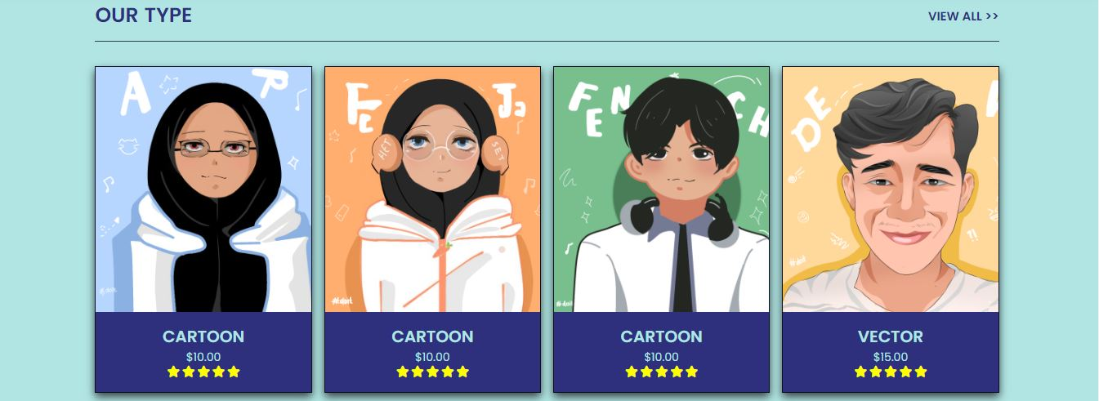

* **Testimoni.html**

<section class="Testimoni" id="Testimoni"></section>

<section>

    <h1 class="title">Testi <span>moni</span> <a href="#">read more >></a> </h1>

</section>

<section class="roadmap" id="roadmap">

    <div class="swiper mySwiper roadmap-slider">

        <div class="swiper-wrapper wrapper">

            <div class="swiper-slide slide">

                <i class="fas fa-quote-right"></i>

                <div class="user">

                    <img decoding="async" src="img/view1.png">

                    <div class="user-info">

                        <h3>Rosalind✅</h3>

                        <div class="star">

                            <i class="fa fa-star"></i>

                            <i class="fa fa-star"></i>

                            <i class="fa fa-star"></i>

                            <i class="fa fa-star"></i>

                            <i class="fa fa-star"></i>

                            <i class="fa fa-star-half-alt"></i>

                        </div>

                    </div>

                </div>

                <p>I recently commiss to create a custom artwork, and the final piece left me in awe.

                    The artistry and creativity displayed in the work are exceptional.

                    The colors and composition are simply stunning.

                    captured the essence of my vision beautifully.</p>

            </div>

            <div class="swiper-slide slide">

                <i class="fas fa-quote-right"></i>

                <div class="user">

                    <img decoding="async" src="img/view2.png">

                    <div class="user-info">

                        <h3>Ophelia✅</h3>

                        <div class="star">

                            <i class="fa fa-star"></i>

                            <i class="fa fa-star"></i>

                            <i class="fa fa-star"></i>

                            <i class="fa fa-star"></i>

                            <i class="fa fa-star"></i>

                            <i class="fa fa-star-half-alt"></i>

                        </div>

                    </div>

                </div>

                <p>The artwork exceeded my expectations in every way.

                    The attention to detail, creativity, and use of colors are exceptional.

                    truly brought my vision to life, and I couldn't be happier with the final product.

                    The entire commission process was smooth.</p>

            </div>

            <div class="swiper-slide slide">

                <i class="fas fa-quote-right"></i>

                <div class="user">

                    <img decoding="async" src="img/view3.png">

                    <div class="user-info">

                        <h3>Vivienne✅</h3>

                        <div class="star">

                            <i class="fa fa-star"></i>

                            <i class="fa fa-star"></i>

                            <i class="fa fa-star"></i>

                            <i class="fa fa-star"></i>

                            <i class="fa fa-star"></i>

                            <i class="fa fa-star-half-alt"></i>

                        </div>

                    </div>

                </div>

                <p>I highly recommend their artistry to anyone looking for unique and personalized artwork.

                    because the result is truly a masterpiece. artwork not only met but exceeded my expectations.

                    The artist's talent and skill are evident in every brushstroke the attention to detail is astonishing.</p>

            </div>

</section>

* **Screenshoot Testimoni.html**

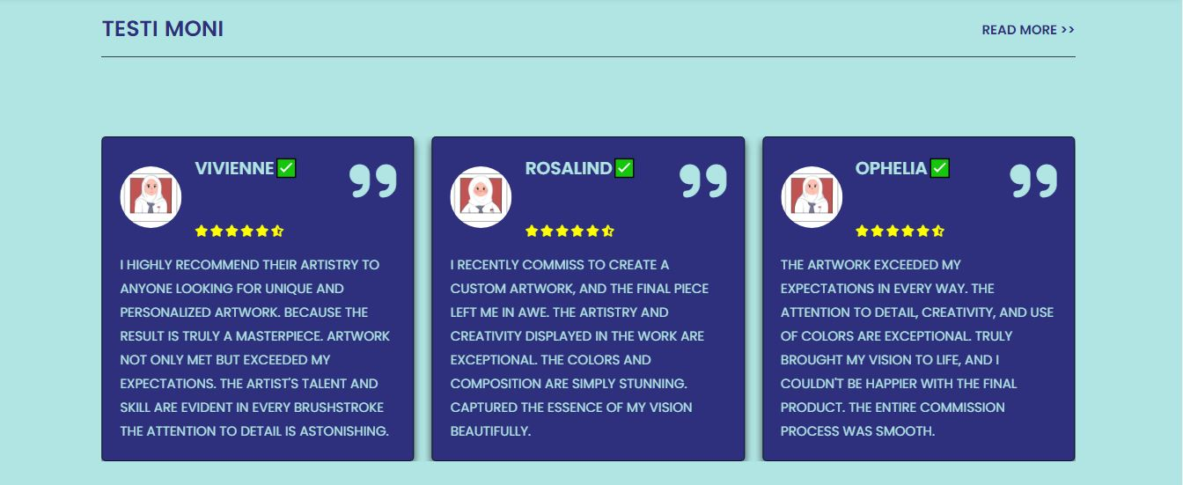

* **Footer contact.html**

<section class="Contact" id="Contact"></section>

<section class="footer">

    <div class="box-container">

        <div class="box">

            <h3>quick links</h3>

                <a href="#home"> <i class="fa fa-arrow-right"></i>Home</a>

                <a href="#about"> <i class="fa fa-arrow-right"></i>About</a>

                <a href="#ourtype"> <i class="fa fa-arrow-right"></i>OurType</a>

                <a href="#Testimoni"> <i class="fa fa-arrow-right"></i>Testimoni</a>

                <a href="#contact"> <i class="fa fa-arrow-right"></i>Contact</a>

        </div>

        <div class="box">

            <h3>extra links</h3>

                <a href="#"> <i class="fa fa-arrow-right"></i> my favorite</a>

                <a href="#"> <i class="fa fa-arrow-right"></i> my wishlist</a>

                <a href="#"> <i class="fa fa-arrow-right"></i> my account</a>

        </div>

        <div class="box">

            <h3>follow us</h3>

            <a href="https://www.facebook.com/gabriel.fizar"> <i class="fab fa-facebook-f"></i> facebook</a>

            <a href="https://instagram.com/__wtfzx?igshid=ZW9memh2M2l4a2l3"> <i class="fab fa-instagram"></i> instagram</a>

            <a href="https://wa.me/c/6288902028471"> <i class="fab fa-whatsapp"></i> whatsapp</a>

        </div>

        <div class="box">

            <h3>newsletter</h3>

            <p>subscribe for latest update</p>

            <form action="">

                <input type="email" placeholder="enter your email address">

                <input type="submit" value="subscribe" class="btn">

            </form>

            <img decoding="async" src="img/payment.png" class="payments">

        </div>

</div>

</section>

<section class="credit">created by <span>Gina Nur Safa</span> || XII Multimedia</section> <script src="https://unpkg.com/swiper@8/swiper-bundle.min.js" defer data-deferred="1"></script>  <script src="main.js" defer data-deferred="1"></script> </body>

</html>

* 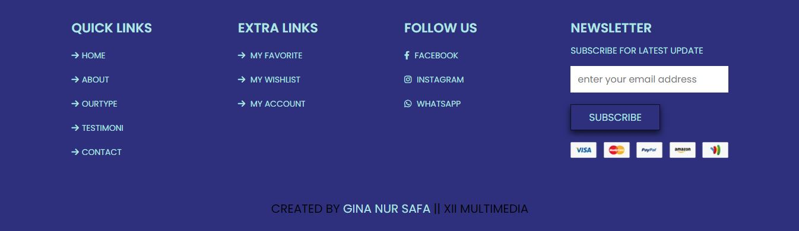**Screenshoot Footer index.hmtl**
* **My Ptofile index2.html**

<!DOCTYPE html>

<html lang="en">

  <head>

    <meta charset="UTF-8" />

    <meta http-equiv="X-UA-Compatible" content="IE=edge" />

    <meta name="viewport" content="width=device-width, initial-scale=1.0" />

    <title>My Profile</title>

    <!--

    - favicon

  -->

    <link

      rel="shortcut icon"

      href="./assets/images/logo.ico"

      type="image/x-icon"

    />

    <!--

    - custom css link

  -->

    <link rel="stylesheet" href="styleprofile.css"/>

    <!--

    - google font link

  -->

    <link rel="preconnect" href="https://fonts.googleapis.com" />

    <link rel="preconnect" href="https://fonts.gstatic.com" crossorigin />

    <link

      href="https://fonts.googleapis.com/css2?family=Poppins:wght@300;400;500;600&display=swap"

      rel="stylesheet"

    />

  </head>

  <body>

    <!--

    - #MAIN

  -->

    <main>

      <!--

      - #SIDEBAR

    -->

      <aside class="sidebar" data-sidebar>

        <div class="sidebar-info">

          <figure class="avatar-box">

            <img

              src="./img/profile.jpg"

              alt="Gina Nur Safa"

              width="80"

            />

          </figure>

          <div class="info-content">

            <h1 class="name" title="Dini Kayla Putri">Gina Nur Safa</h1>

            <p class="title">Pelajar</p>

          </div>

          <button class="info_more-btn" data-sidebar-btn>

            <span>Show Contacts</span>

            <ion-icon name="chevron-down"></ion-icon>

          </button>

        </div>

        <div class="sidebar-info_more">

          <div class="separator"></div>

          <ul class="contacts-list">

            <li class="contact-item">

              <div class="icon-box">

                <ion-icon name="mail-outline"></ion-icon>

              </div>

              <div class="contact-info">

                <p class="contact-title">Email</p>

                <a href="mailto:richard@example.com" class="contact-link"

                  >nursafagina@gmail.com</a

                >

              </div>

            </li>

            <li class="contact-item">

              <div class="icon-box">

                <ion-icon name="phone-portrait-outline"></ion-icon>

              </div>

              <div class="contact-info">

                <p class="contact-title">Phone</p>

                <a href="tel:+12133522795" class="contact-link"

                  >+62 896-3780-8106</a

                >

              </div>

            </li>

            <li class="contact-item">

              <div class="icon-box">

                <ion-icon name="location-outline"></ion-icon>

              </div>

              <div class="contact-info">

                <p class="contact-title">Location</p>

                <address>Jakarta, Indonesia</address>

              </div>

            </li>

          </ul>

        </div>

      </aside>

      <!--

      - #main-content

    -->

      <div class="main-content">

        <!--

        - #NAVBAR

      -->

        <nav class="navbar">

          <ul class="navbar-list">

            <li class="navbar-item">

              <a href="index.html" class="navbar-link" data-nav-link>Home</a>

            </li>

          </ul>

        </nav>

        <!--

        - #ABOUT

      -->

        <article class="about active" data-page="about">

          <header>

            <h2 class="h2 article-title">About me</h2>

          </header>

          <section class="about-text">

            <p>

              Hallo, saya adalah seorang ilustrator yang mampu membuat banyak style gambar dimulai dari, chibi,vexel art atupun simple art.

              Saya masih berusia 17 tahun bersekolah di SMKN 50 Jakarta dan memiliki cukup pengalaman di PT Urus Izin Indonesia selama 6 bulan

              sebagai graphic designer melakukan praktik kerja lapangan

            </p>

            <p>

              Jika Anda tertarik untuk bekerja sama atau memiliki pertanyaan lebih lanjut,

              jangan ragu untuk menghubungi saya melalui alamat email atau melalui media sosial saya.

              Bersama saya, setiap proyek menjadi peluang untuk menciptakan keindahan visual yang tak terlupakan.

            </p>

          </section>

          <!--

          - service

        -->

          <section class="service">

            <h3 class="h3 service-title">My Art Work</h3>

            <ul class="service-list">

              <li class="service-item">

                <div class="service-icon-box">

                  <img

                    src="./assets/images/icon-design.svg

                "

                    alt="design icon"

                    width="40"

                  />

                </div>

                <div class="service-content-box">

                  <h4 class="h4 service-item-title">Graphic Designer</h4>

                  <p class="service-item-text">

                    Mampu mendesain website dan foto sesuai kebutuhan.

                  </p>

                </div>

              </li>

              <li class="service-item">

                <div class="service-icon-box">

                  <img

                    src="./assets/img/artwork1.png"

                    alt="camera icon"

                    width="40"

                  />

                </div>

                <div class="service-content-box">

                  <h4 class="h4 service-item-title">Photography</h4>

                  <p class="service-item-text">

                    Mampu melukis kaligrafi.

                  </p>

                </div>

              </li>

            </ul>

          </section>

        </article>

      </div>

    </main>

    <!--

    - custom js link

  -->

    <script src="./assets/js/script2.js"></script>

    <!--

    - ionicon link

  -->

    <script

      type="module"

      src="https://unpkg.com/ionicons@5.5.2/dist/ionicons/ionicons.esm.js"

    ></script>

    <script

      nomodule

      src="https://unpkg.com/ionicons@5.5.2/dist/ionicons/ionicons.js"

    ></script>

  </body>

</html>

* **Screenshoot My Profile index2.html**

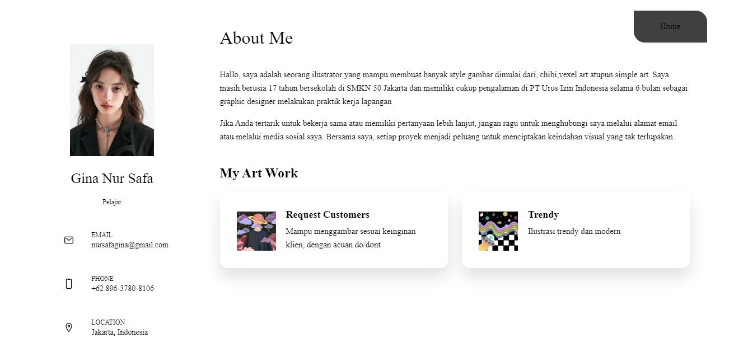

1. **Source code penggunaan CSS**

* **Style.css**

@import url('https://fonts.googleapis.com/css2?family=Poppins:wght@100;300;400;500;600&display=swap');

:root{

--Tusk:#B0E5E3;

--main:#2E307D;

--meet:#FFE9E2;

}

body{

background:var(--Tusk);

}

*{

font-family:'Poppins', sans-serif;

margin: 0;

padding: 0;

box-sizing: border-box;

outline: none;

border: none;

text-transform: uppercase;

text-decoration: none;

transition: .2s linear;

}

html{

font-size: 62.5%;

overflow-x: hidden;

scroll-behavior: smooth;

}

section{

padding: 3rem 9%;

}

.title{

display: flex;

align-items: center;

font-size: 2.5rem;

margin-bottom:3rem;

padding:1.2rem 0;

border-bottom: 1px solid rgba(0,0,0,0.7);

color: var(--main);

}

.title span{

color: var(--main);

padding-left: .7rem;

}

.title a{

margin-left: auto;

color: var(--main);

font-size: 1.5rem;

}

.title a:hover{

color: #fff;

}

.btn{

margin-top: 1rem;

display:inline-block;

padding:.8rem 3rem;

background-color:var(--main);

color:var(--Tusk);

font-size: 1.7rem;

cursor:pointer;

box-shadow: 0 0.5rem 1rem rgba(0,0,0,0.7);

border:0.1rem solid rgba(0,0,0,0.7);

}

.btn:hover{

background: var(--Tusk);

color: var(--main);

box-shadow: 0 0.5rem 1rem rgba(0,0,0,0.1);

}

.header{

position:fixed;

top:0;

left:0;

right:0;

z-index: 1000;

background: var(--main);

display:flex;

align-items: center;

justify-content: space-between;

padding:2rem 9%;

box-shadow: 0 0.5rem 1rem rgba(0,0,0,0.7);

}

.header .logo{

font-size: 2.4rem;

font-weight: bolder;

color: var(--Tusk);

}

.header .logo i{

color: var(--Tusk);

padding-right: .5rem;

}

.header .navbar a{

font-size:1.7rem;

color: var(--Tusk);

margin: 0 1rem;

font-weight: bold;

}

.header .navbar a:hover{

color: #fff;

}

.header .icons div{

font-size: 2.5rem;

margin-left: 1.7rem;

cursor: pointer;

color:var(--Tusk);

}

.header .icons div:hover{

color: #fff;

}

#menu-btn{

display: none;

}

@keyframes fadeLeft{

0%{

opacity: 0;

transform:translateY(-5rem);

}

}

@keyframes fadeUp {

0%{

opacity: 0;

transform: scale(0.5);

}

}

.home{

padding-top: 14rem;

background-color:var(--Tusk);

background-size: cover;

background-position: center;

position: relative;

}

.home .slides-container .slide{

display:flex;

align-items:center;

flex-wrap: wrap;

gap: 1.5rem;

display:none;

}

.home .slides-container .slide.active{

display: flex;

}

.home .slides-container .slide .content{

flex: 1 1 40rem;

animation:fadeLeft .4s linear .4s backwards;

}

.home .slides-container .slide .content h3{

color: var(--main);

font-size: 2.0rem;

align-items: center;

}

.home .slides-container .slide .content .slideimg img{

display: inline-block;

}

.home .slides-container .slide .img{

flex: 1 1 40rem;

margin: 3rem 0;

}

.home .slides-container .slide .img img{

width: 100%;

height:490px;

animation:fadeUp .4s linear;

}

.home #next-slide,

.home #prev-slide{

position: absolute;

top: 50%;

transform:translateY(-50%);

height:5rem;

width:5rem;

line-height: 5rem;

box-shadow: 0 0.5rem 1rem rgba(0,0,0,0.7);

border: 0.1rem solid rgba(0,0,0,0.7);

text-align: center;

background:var(--main);

font-size: 2rem;

color: var(--Tusk);

cursor: pointer;

}

.home #next-slide:hover,

.home #prev-slide:hover{

background: var(--Tusk);

color: var(--main);

box-shadow: 0 0.5rem 1rem rgba(0,0,0,0.1);

}

.home #prev-slide{

left: 2rem;

}

.home #next-slide{

right: 2rem;

}

.banner-container{

background:var(--Tusk);

display:flex;

flex-wrap: wrap;

gap: 1.5rem;

}

.banner-container .banner{

flex: 1 1 35rem;

height:65rem;

overflow: hidden;

position: relative;

box-shadow: 0 0.5rem 1rem rgba(0,0,0,0.7);

border: 0.1rem solid rgba(0,0,0,0.7);

}

.banner-container .banner img{

height:100%;

width:100%;

object-fit: cover;

}

.banner-container .banner .content{

position: absolute;

top: 70%;

left: 4%;

transform:translateY(-50%);

}

.banner-container .banner .content h3{

font-size: 3rem;

color: #fff;

text-shadow:0 0.5rem 1rem rgba(0,0,0,0.7);

}

.banner-container .banner .content span{

font-size: 2.5rem;

color: #000;;

text-shadow: 0 0.5rem 1rem rgba(0,0,0,0.7);

}

.banner-container .banner:hover img{

transform:scale(1.2) rotate(-5deg);

}

.ourtype .box-container{

display:grid;

grid-template-columns: repeat(auto-fit, minmax(25rem, 1fr));

gap: 1.5rem;

}

.ourtype .box-container .box{

position:relative;

background-color:var(--main);

text-align: center;

overflow: hidden;

box-shadow: 0 0.5rem 1rem rgba(0,0,0,0.7);

border: 0.1rem solid rgba(0,0,0,0.7);

}

.ourtype .box-container .box:hover .icons{

top: 0;

height:35rem;

}

.ourtype .box-container .box .icons{

position:absolute;

top: -105%;

left: 0;

height:35rem;

width: 100%;

display:flex;

align-items:center;

justify-content:center;

background:var(--main);

gap: 1rem;

}

.ourtype .box-container .box .icons a{

font-size: 2rem;

height:5rem;

width:5rem;

line-height: 5rem;

background: var(--Tusk);

box-shadow: 0 0.5rem 1rem rgba(0,0,0,0.1);

color:var(--main)

}

.ourtype .box-container .box .icons a:hover{

background: var(--Tusk);

color:var(--main);

height:17rem;

}

.ourtype .box-container .box .img{

height:30rem;

width:30rem;

overflow:hidden;

}

.ourtype .box-container .box .img img{

height:100%;

width:100%;

object-fit:cover;

}

.ourtype .box-container .box .content{

padding:1.5rem;

}

.ourtype .box-container .box .content .price{

font-size: 1.4rem;

color: var(--Tusk);

}

.ourtype .box-container .box .content h3{

font-size:2rem;

color: var(--Tusk);

}

.ourtype .box-container .box .content .stars i{

font-size: 1.4rem;

color: yellow;

}

.firepit{

display: flex;

align-items: center;

flex-wrap: wrap;

gap: 1.5rem;

}

.firepit .img{

flex: 1 1 40rem;

}

.firepit .img img{

width: 100%;

height:55rem;

overflow: hidden;

object-fit: cover;

box-shadow: 0 0.5rem 1rem rgba(0,0,0,0.7);

border: 0.1rem solid rgba(0,0,0,0.7);

}

.firepit .content{

flex: 1 1 40rem;

}

.firepit .content h3{

color: var(--main);

font-size: 3rem;

padding-top: .5rem;

}

.firepit .content p{

color: var(--main);

font-size:2rem;

padding:1rem 0;

}

.about {

display: flex;

align-items: center;

flex-wrap: wrap;

gap:2rem;

}

.about .img{

flex: 1 1 42rem;

padding-bottom: 5rem;

padding-right: 5rem;

}

.about .img img{

width: 100%;

box-shadow: 4rem 4rem 0 #eee;

}

.about .content{

flex: 1 1 42rem;

}

.about .content .box{

padding: 3rem;

background:var(--Tusk);

}

.about .content .box h3{

font-size:2.5rem;

color: #222;

}

.about .content .box p{

padding: 1rem 0;

line-height: 2;

color: #666;

font-size:1.4rem;

}

.about .content .icons-container{

display: flex;

flex-wrap: wrap;

align-items: flex-end;

gap: 2rem;

margin-top: 2rem;

}

.about .content .icons-container .icons{

flex: 1 1 16rem;

background: #eee;

padding:2rem;

text-align: center;

}

.about .content .icons-container .icons i{

color: #F08080;

margin-bottom: 1rem;

font-size: 5rem;

}

.about .content .icons-container .icons p{

font-size:1.4rem;

color: #666;

}

.roadmap .slide{

padding:2rem;

box-shadow: 0 0.5rem 1rem rgba(0,0,0,0.7);

border: 0.1rem solid rgba(0,0,0,0.7);

border-radius: .5rem;

position: relative;

background:var(--main);

}

.roadmap .slide .fa-quote-right{

position: absolute;

top: 2rem;

right: 2rem;

font-size: 6rem;

color: var(--Tusk);

}

.roadmap .slide .user{

display:flex;

gap: 1.5rem;

align-items: center;

padding-bottom: 1.5rem;

}

.roadmap .slide .user img{

height:7rem;

width:7rem;

border-radius: 50%;

object-fit: cover;

}

.roadmap .slide .user h3{

color: var(--Tusk);

font-size: 2rem;

padding-bottom:5rem;

}

.roadmap .slide .user i{

font-size: 1.3rem;

color:yellow;

}

.roadmap .slide p{

font-size: 1.5rem;

line-height: 1.8;

color:var(--Tusk);

}

.teams .box-container{

display: grid;

grid-template-columns: repeat(auto-fit, minmax(30rem, 1fr));

gap:1.5rem;

}

.teams .box-container .box{

border: 0.1rem solid rgba(0,0,0,0.7);

box-shadow: 0 0.5rem 1rem rgba(0,0,0,0.7);

background:var(--main);

}

.teams .box-container .box .img{

height:25rem;

width:25rem;

overflow:hidden;

}

.teams .box-container .box .img:hover img{

transform:scale(1.2);

}

.teams .box-container .box .img img{

height:100%;

width:100%;

object-fit: cover;

}

.teams .box-container .box .content{

padding:2rem 1.5rem;

}

.teams .box-container .box .content .icons{

border-radius:0.1rem solid rgba(0,0,0,0.1);

padding-bottom: 1.7rem;

margin-bottom: 1.7rem;

display: flex;

align-items: center;

justify-content:space-between;

}

.teams .box-container .box .content .icons a{

font-size: 1.4rem;

color: var(--Tusk);

}

.teams .box-container .box .content .icons a:hover{

color: #fff;

}

.teams .box-container .box .content .icons a i{

color: var(--Tusk);

padding-right:.5rem;

}

.teams .box-container .box .content h3{

font-size: 2.2rem;

color: var(--Tusk);

}

.teams .box-container .box .content p{

font-size: 1.4rem;

color: var(--Tusk);

line-height: 2;

padding:1rem 0;

}

.faq .icons-container{

display:grid;

grid-template-columns: repeat(auto-fit, minmax(29rem, 1fr));

gap: 1.5rem;

}

.faq .icons-container .icons{

text-align:center;

border: 0.1rem solid rgba(0,0,0,0.7);

box-shadow: 0 0.5rem 1rem rgba(0,0,0,0.7);

padding: 2rem;

background:var(--main);

}

.faq .icons-container .icons i{

height:6rem;

width:6rem;

line-height: 6rem;

font-size: 2.5rem;

background: var(--Tusk);

color:var(--main);

border-radius:50%;

}

.faq .icons-container .icons h3{

color: var(--Tusk);

font-size: 2rem;

padding:1rem 0;

}

.faq .icons-container .icons p{

color: var(--Tusk);

font-size: 1.5rem;

line-height: 2;

}

.footer{

background:var(--main);

}

.footer .box-container{

display:grid;

grid-template-columns: repeat(auto-fit, minmax(25rem, 1fr));

gap:1.5rem;

}

.footer .box-container .box h3{

font-size: 2.2rem;

color: var(--Tusk);

padding:1rem 0;

}

.footer .box-container .box p{

font-size: 1.5rem;

color: var(--Tusk);

padding-bottom: .5rem;

}

.footer .box-container .box a{

font-size: 1.4rem;

color: var(--Tusk);

padding: 1rem 0;

display:block;

}

.footer .box-container .box a:hover{

color: #fff;

}

.footer .box-container .box a:hover i{

padding-right: 2rem;

}

.footer .box-container .box a i{

padding-right:.5rem;

color: var(--Tusk);

}

.footer .box-container .box form input[type="email"]{

width: 100%;

padding:1rem 1.2rem;

font-size: 1.6rem;

color: var(--Tusk);

margin: 1rem 0;

text-transform: none;

}

.footer .box-container .box .payments{

width: 100%;

margin-top: 2rem;

}

.credit{

text-align: center;

background:var(--main);

color:#000;

font-size: 2rem;

}

.credit span{

color:var(--Tusk);

}

/* media queries */

@media(max-width:991px){

html{

font-size: 55%;

}

.header{

padding:2rem;

}

section{

padding:3rem 2rem;

}

.home #next-slide,

.home #prev-slide{

transform:translateY(0);

top: 88%;

}

.home #prev-slide{

left:auto;

right: 8rem;

}

}

@media(max-width:768px){

#menu-btn{

display: inline-block;

}

.header .navbar{

position:absolute;

top:99%;

left:0;

right:0;

background:var(--main);

border-top:1px solid rgba(0,0,0,0.1);

clip-path: polygon(0 0, 100% 0, 100% 0, 0 0);

}

.header .navbar.active{

clip-path: polygon(0 0, 100% 0, 100% 100%, 0% 100%);

}

.header .navbar a{

margin: 1.5rem;

padding:1.5rem;

background:var(--Tusk);

font-size: 2rem;

display:block;

border-radius: .5rem;

}

}

@media(max-width:450px){

html{

font-size: 50%;

}

.home .slides-container .slide .content .slideimg img{

display: none;

}

.home .slides-container .slide .content h3{

font-size:1rem;

}

.story .box-container .box .img{

width: 100%;

}

}

**Penggunaan css**

1. **Foto**



1. **Vidio dan audio**

**Style2.css**

\-----------------------------------\#style.css

\-----------------------------------/

:root {

  /**

   * colors

   */

  --rich-black-fogra-39_50: hsla(0, 0%, 5%, 0.5);

  --rich-black-fogra-39: hsl(0, 0%, 5%);

  --indian-yellow_10: hsla(36, 61%, 58%, 0.1);

  --indian-yellow: #B0E5E3(36, 61%, 58%);

  --harvest-gold: #B0E5E3(36, 66%, 53%);

  --eerie-black-1: hsl(0, 0%, 14%);

  --eerie-black-2: hsl(0, 0%, 12%);

  --eerie-black-2_85: hsla(0, 0%, 12%, 0.85);

  --eerie-black-3: hsl(0, 0%, 8%);

  --sonic-silver: hsl(0, 0%, 44%);

  --davys-gray: hsl(210, 47%, 41%);

  --light-gray: hsl(224, 29%, 15%);

  --platinum: hsl(0, 100%, 15%);

  --black_30: hsla(0, 0%, 0%, 0.3);

  --white_10: hsla(0, 0%, 100%, 0.1);

  --white_30: hsla(0, 0%, 100%, 0.3);

  --white_50: hsla(0, 0%, 100%, 0.5);

  --white_90: hsla(0, 0%, 100%, 0.9);

  --white: hsl(0, 0%, 100%);

  --jet: hsl(0, 0%, 21%);

  /* gradient */

  --bg-gradient-onyx: linear-gradient(

    to bottom right,

    hsl(240, 22%, 46%) 3%,

    hsl(0, 65%, 50%) 97%

  );

  --bg-gradient-jet: linear-gradient(

      to bottom right,

      hsla(240, 1%, 18%, 0.251) 0%,

      hsla(240, 2%, 11%, 0) 100%

    ),

    hsl(240, 2%, 13%);

  --bg-gradient-yellow-1: linear-gradient(

    to bottom right,

    #3a3ecc(45, 100%, 71%) 0%,

    hsla(36, 100%, 69%, 0) 50%

  );

  --bg-gradient-yellow-2: linear-gradient(

      135deg,

      hsla(45, 100%, 71%, 0.251) 0%,

      hsla(35, 100%, 68%, 0) 59.86%

    ),

    hsl(240, 2%, 13%);

  --border-gradient-onyx: linear-gradient(

    to bottom right,

    hsl(0, 0%, 25%) 0%,

    hsla(0, 0%, 25%, 0) 50%

  );

  --text-gradient-yellow: linear-gradient(

    to right,

    hsl(45, 100%, 72%),

    hsl(140, 100%, 68%)

  );

  /* solid */

  --jet: hsl(0, 0%, 22%);

  --onyx: hsl(240, 1%, 17%);

  --eerie-black-1: hsl(240, 2%, 13%);

  --eerie-black-2: hsl(240, 2%, 12%);

  --smoky-black: hsl(0, 0%, 7%);

  --white-1: hsl(0, 0%, 100%);

  --white-2: hsl(0, 0%, 98%);

  --orange-yellow-crayola: hsl(45, 100%, 72%);

  --vegas-gold: hsl(45, 54%, 58%);

  --light-gray: hsl(0, 0%, 84%);

  --light-gray-70: hsla(0, 0%, 84%, 0.7);

  --bittersweet-shimmer: hsl(0, 43%, 51%);

  /**

   * typography

   */

  /* font-family */

  --ff-poppins: "Poppins", sans-serif;

  --ff-rubik: "Rubik", sans-serif;

  --ff-poppins: "Poppins", sans-serif;

  /* font-size */

  --fs-1: 24px;

  --fs-2: 18px;

  --fs-3: 17px;

  --fs-4: 16px;

  --fs-5: 15px;

  --fs-6: 14px;

  --fs-7: 13px;

  --fs-8: 11px;

  /* font-weight */

  --fw-300: 300;

  --fw-400: 400;

  --fw-500: 500;

  --fw-600: 600;

  --fs-40: 4rem;

  --fs-30: 3.5rem;

  --fs-24: 2.4rem;

  --fs-18: 1.8rem;

  --fs-14: 1.4rem;

  --fs-13: 1.3rem;

  --fw-300: 300;

  --fw-500: 500;

  --fw-600: 600;

  --fw-700: 700;

  /**

   * shadow

   */

  --shadow-1: -4px 8px 24px hsla(0, 0%, 0%, 0.25);

  --shadow-2: 0 16px 30px hsla(0, 0%, 0%, 0.25);

  --shadow-3: 0 16px 40px hsla(0, 0%, 0%, 0.25);

  --shadow-4: 0 25px 50px hsla(0, 0%, 0%, 0.15);

  --shadow-5: 0 24px 80px hsla(0, 0%, 0%, 0.25);

  --shadow-6: 10px 0 60px hsla(0, 0%, 15%, 0.07);

  --shadow-7: 10px 0 60px hsla(0, 0%, 15%, 0.1);

  /**

   * transition

   */

  --transition-1: 0.25s ease;

  --transition-2: 0.5s ease-in-out;

}

*,

*::before,

*::after {

  margin: 0;

  padding: 0;

  box-sizing: border-box;

}

a {

  text-decoration: none;

}

li {

  list-style: none;

}

img,

ion-icon,

a,

button,

time,

span {

  display: block;

}

button {

  font: inherit;

  background: none;

  border: none;

  text-align: left;

  cursor: pointer;

}

input,

textarea {

  display: block;

  width: 100%;

  background: none;

  font: inherit;

}

::selection {

  background: var(--orange-yellow-crayola);

  color: var(--smoky-black);

}

:focus {

  outline-color: var(--orange-yellow-crayola);

}

html {

  font-family: var(--ff-poppins);

}

body {

  background: var(--white);

}

.sidebar,

article {

  background: var(--harvest-gold);

  border: 1px solid var(--indian-yellow);

  border-radius: 20px;

  padding: 15px;

  box-shadow: var(--shadow-1);

  z-index: 1;

}

.separator {

  width: 100%;

  height: 1px;

  background: var(--harvest-gold);

  margin: 16px 0;

}

.icon-box {

  position: relative;

  background: var(--border-gradient-yellow-1);

  width: 30px;

  height: 30px;

  border-radius: 8px;

  display: flex;

  justify-content: center;

  align-items: center;

  font-size: 16px;

  color: var(--orange-yellow-crayola);

  box-shadow: var(--shadow-7);

  z-index: 1;

}

.icon-box::before {

  content: "";

  position: absolute;

  inset: 1px;

  background: var(--eerie-black-1);

  border-radius: inherit;

  z-index: -1;

}

.icon-box ion-icon {

  --ionicon-stroke-width: 35px;

}

article {

  display: none;

}

article.active {

  display: block;

  animation: fade 0.5s ease backwards;

}

@keyframes fade {

  0% {

    opacity: 0;

  }

  100% {

    opacity: 1;

  }

}

.h2,

.h3,

.h4,

.h5 {

  color: var(--white-1);

  text-transform: capitalize;

}

.h2 {

  font-size: var(--fs-1);

}

.h3 {

  font-size: var(--fs-2);

}

.h4 {

  font-size: var(--fs-4);

}

.h5 {

  font-size: var(--fs-7);

  font-weight: var(--fw-500);

}

.article-title {

  position: relative;

  padding-bottom: 7px;

}

.article-title::after {

  content: "";

  position: absolute;

  bottom: 0;

  left: 0;

  width: 30px;

  height: 3px;

  background: var(--text-gradient-yellow);

  border-radius: 3px;

}

.content-card {

  position: relative;

  background: var(--eerie-black-1);

  padding: 15px;

  padding-top: 45px;

  border-radius: 14px;

  box-shadow: var(--shadow-7);

  cursor: pointer;

  z-index: 1;

}

.content-card::before {

  content: "";

  position: absolute;

  inset: 1px;

  background: var(--platinum);

  border-radius: inherit;

  z-index: -1;

}

main {

  margin: 15px 12px;

  margin-bottom: 75px;

  min-width: 259px;

}

.sidebar {

  margin-bottom: 15px;

  max-height: 112px;

  overflow: hidden;

  transition: var(--transition-2);

}

.sidebar.active {

  max-height: 405px;

}

.sidebar-info {

  position: relative;

  display: flex;

  justify-content: flex-start;

  align-items: center;

  gap: 15px;

}

.avatar-box {

  background: var(--white_90);

  border-radius: 20px;

}

.info-content .name {

  color: var(--white);

  font-size: var(--fs-3);

  font-weight: var(--fw-500);

  letter-spacing: -0.25px;

  margin-bottom: 10px;

}

.info-content .title {

  color: var(--white-1);

  background: var(--onyx);

  font-size: var(--fs-8);

  font-weight: var(--fw-300);

  width: max-content;

  padding: 3px 12px;

  border-radius: 8px;

}

.info_more-btn {

  position: absolute;

  top: -15px;

  right: -15px;

  border-radius: 0 15px;

  font-size: 13px;

  color: var(--orange-yellow-crayola);

  background: var(--border-gradient-onyx);

  padding: 10px;

  box-shadow: var(--shadow-2);

  transition: var(--transition-1);

  z-index: 1;

}

.info_more-btn::before {

  content: "";

  position: absolute;

  inset: 1px;

  border-radius: inherit;

  background: var(--bg-gradient-jet);

  transition: var(--transition-1);

  z-index: -1;

}

.info_more-btn:hover,

.info_more-btn:focus {

  background: var(--bg-gradient-yellow-1);

}

.info_more-btn:hover::before,

.info_more-btn:focus::before {

  background: var(--bg-gradient-yellow-2);

}

.info_more-btn span {

  display: none;

}

.sidebar-info_more {

  opacity: 0;

  visibility: hidden;

  transition: var(--transition-2);

}

.sidebar.active .sidebar-info_more {

  opacity: 1;

  visibility: visible;

}

.contacts-list {

  display: grid;

  grid-template-columns: 1fr;

  gap: 16px;

}

.contact-item {

  min-width: 100%;

  display: flex;

  align-items: center;

  gap: 16px;

}

.contact-info {

  max-width: calc(100% - 46px);

  width: calc(100% - 46px);

}

.contact-title {

  color: var(--eerie-black-1);

  font-size: var(--fs-8);

  text-transform: uppercase;

  margin-bottom: 2px;

  font-weight: var(--fw-500);

}

.contact-info :is(.contact-link, time, address) {

  color: var(--white);

  font-size: var(--fs-7);

}

.contact-info address {

  font-style: normal;

}

.social-list {

  display: flex;

  justify-content: flex-start;

  align-items: center;

  gap: 15px;

  padding-bottom: 4px;

  padding-left: 7px;

}

.social-item .social-link {

  color: var(--light-gray-70);

  font-size: 18px;

}

.social-item .social-link:hover {

  color: var(--light-gray);

}

.navbar {

  position: fixed;

  bottom: 0;

  left: 0;

  width: 100%;

  background: hsla(0, 0%, 0%, 0.75);

  backdrop-filter: blur(10px);

  border: 1px solid var(--jet);

  border-radius: 12px 12px 0 0;

  box-shadow: var(--shadow-2);

  z-index: 5;

}

.navbar-list {

  display: flex;

  flex-wrap: wrap;

  justify-content: center;

  align-items: center;

  padding: 0 10px;

}

.navbar-link {

  color: var(--white);

  font-size: var(--fs-8);

  padding: 20px 7px;

  transition: color var(--transition-1);

}

.navbar-link:hover,

.navbar-link:focus {

  color: var(--orange-yellow-crayola);

}

.navbar-link.active {

  color: var(--orange-yellow-crayola);

}

.about .article-title {

  margin-bottom: 15px;

}

.about-text {

  color: var(--white);

  font-size: var(--fs-6);

  font-weight: var(--fw-300);

  line-height: 1.6;

}

.about-text p {

  margin-bottom: 15px;

}

/**

 * #service

 */

.service {

  margin-bottom: 35px;

}

.service-title {

  margin-bottom: 20px;

}

.service-list {

  display: grid;

  grid-template-columns: 1fr;

  gap: 20px;

}

.service-item {

  position: relative;

  background: var(--border-gradient-onyx);

  padding: 20px;

  border-radius: 14px;

  box-shadow: var(--shadow-2);

  z-index: 1;

}

.service-item::before {

  content: "";

  position: absolute;

  inset: 1px;

  background: var(--bg-gradient-jet);

  border-radius: inherit;

  z-index: -1;

}

.service-icon-box {

  margin-bottom: 10px;

}

.service-icon-box img {

  margin: auto;

}

.service-content-box {

  text-align: center;

}

.service-item-title {

  margin-bottom: 7px;

}

.service-item-text {

  color: var(--light-gray);

  font-size: var(--fs-6);

  font-weight: var(--fw-3);

  line-height: 1.6;

}

/**

 * responsive larger than 450px screen

 */

@media (min-width: 450px) {

}

/**

 * responsive larger than 580px screen

 */

@media (min-width: 580px) {

  /**

   * CUSTOM PROPERTY

   */

  :root {

    /**

     * typography

     */

    --fs-1: 32px;

    --fs-2: 24px;

    --fs-3: 26px;

    --fs-4: 18px;

    --fs-6: 15px;

    --fs-7: 15px;

    --fs-8: 12px;

  }

  /**

   * #REUSED STYLE

   */

  .sidebar,

  article {

    width: 520px;

    margin-inline: auto;

    padding: 30px;

  }

  .article-title {

    font-weight: var(--fw-600);

    padding-bottom: 15px;

  }

  .article-title::after {

    width: 40px;

    height: 5px;

  }

  .icon-box {

    width: 48px;

    height: 48px;

    border-radius: 12px;

    font-size: 18px;

  }

  /**

   * #MAIN

   */

  main {

    margin-top: 60px;

    margin-bottom: 100px;

  }

  /**

   * #SIDEBAR

   */

  .sidebar {

    max-height: 180px;

    margin-bottom: 30px;

  }

  .sidebar.active {

    max-height: 584px;

  }

  .sidebar-info {

    gap: 25px;

  }

  .avatar-box {

    border-radius: 30px;

  }

  .avatar-box img {

    width: 120px;

  }

  .info-content .name {

    margin-bottom: 15px;

  }

  .info-content .title {

    padding: 5px 18px;

  }

  .info_more-btn {

    top: -30px;

    right: -30px;

    padding: 10px 15px;

  }

  .info_more-btn span {

    display: block;

    font-size: var(--fs-8);

  }

  .info_more-btn ion-icon {

    display: none;

  }

  .separator {

    margin: 32px 0;

  }

  .contacts-list {

    gap: 20px;

  }

  .contact-info {

    max-width: calc(100% - 64px);

    width: calc(100% - 64px);

  }

  /**

   * #NAVBAR

   */

  .navbar {

    border-radius: 20px 20px 0 0;

  }

  .navbar-list {

    gap: 20px;

  }

  .navbar-link {

    --fs-8: 14px;

  }

  /**

   * #ABOUT

   */

  .about .article-title {

    margin-bottom: 20px;

  }

  .about-text {

    margin-bottom: 40px;

  }

  /* service */

  .service-item {

    display: flex;

    justify-content: flex-start;

    align-items: flex-start;

    gap: 18px;

    padding: 30px;

  }

  .service-icon-box {

    margin-bottom: 0;

    margin-top: 5px;

  }

  .service-content-box {

    text-align: left;

  }

}

/**

 * responsive larger than 768px screen

 */

@media (min-width: 768px) {

  /**

   * REUSED STYLE

   */

  .sidebar,

  article {

    width: 700px;

  }

  .has-scrollbar::-webkit-scrollbar-button {

    width: 100px;

  }

  /**

   * SIDEBAR

   */

  .contacts-list {

    grid-template-columns: 1fr 1fr;

    gap: 30px 15px;

  }

  /**

   * NAVBAR

   */

  .navbar-link {

    --fs-8: 15px;

  }

  /**

   * ABOUT

   */

}

/**

 * responsive larger than 1024px screen

 */

@media (min-width: 1024px) {

  /**

   * CUSTOM PROPERTY

   */

  :root {

    /**

    * shadow

    */

    --shadow-1: -4px 8px 24px hsla(0, 4%, 5%, 0.125);

    --shadow-2: 0 16px 30px hsla(0, 0%, 0%, 0.125);

    --shadow-3: 0 16px 40px hsla(0, 0%, 0%, 0.125);

  }

  /**

   * REUSED STYLE

   */

  .sidebar,

  article {

    width: 950px;

    box-shadow: var(--shadow-6);

  }

  /**

   * MAIN

   */

  main {

    margin-bottom: 60px;

  }

  .main-content {

    position: relative;

    width: max-content;

    margin: auto;

  }

  /**

   * NAVBAR

   */

  .navbar {

    position: absolute;

    bottom: auto;

    top: 0;

    left: auto;

    right: 0;

    width: max-content;

    border-radius: 0 20px;

    padding: 0 20px;

    box-shadow: none;

  }

  .navbar-list {

    gap: 30px;

    padding: 0 20px;

  }

  .navbar-link {

    font-weight: var(--fw-500);

  }

  /**

   * ABOUT

   */

  /* service */

  .service-list {

    grid-template-columns: 1fr 1fr;

    gap: 20px 25px;

  }

}

/**

 * responsive larger than 1250px screen

 */

@media (min-width: 1250px) {

  /**

   * RESET

   */

  body::-webkit-scrollbar-thumb {

    border: 5px solid var(--smoky-black);

    background: hsla(0, 0%, 100%, 0.1);

    border-radius: 20px;

    box-shadow: inset 1px 1px 0 hsla(0, 0%, 100%, 0.11),

      inset -1px -1px 0 hsla(0, 0%, 100%, 0.11);

  }

  body::-webkit-scrollbar-thumb:hover {

    background: hsla(0, 0%, 100%, 0.15);

  }

  body::-webkit-scrollbar-button {

    height: 60px;

  }

  /**

   * REUSED STYLE

   */

  .sidebar,

  article {

    width: auto;

  }

  article {

    min-height: 100%;

  }

  /**

   * MAIN

   */

  main {

    max-width: 1200px;

    margin-inline: auto;

    display: flex;

    justify-content: center;

    align-items: stretch;

    gap: 25px;

  }

  .main-content {

    min-width: 75%;

    width: 75%;

    margin: 0;

  }

  /**

   * SIDEBAR

   */

  .sidebar {

    position: sticky;

    top: 60px;

    max-height: max-content;

    height: 100%;

    margin-bottom: 0;

    padding-top: 60px;

    z-index: 1;

  }

  .sidebar-info {

    flex-direction: column;

  }

  .avatar-box img {

    width: 150px;

  }

  .info-content .name {

    white-space: nowrap;

    text-align: center;

  }

  .info-content .title {

    margin: auto;

  }

  .info_more-btn {

    display: none;

  }

  .sidebar-info_more {

    opacity: 1;

    visibility: visible;

  }

  .contacts-list {

    grid-template-columns: 1fr;

  }

  .contact-info :is(.contact-link) {

    white-space: nowrap;

    overflow: hidden;

    text-overflow: ellipsis;

  }

  .contact-info :is(.contact-link, time, address) {

    --fs-7: 14px;

    font-weight: var(--fw-300);

  }

  .separator:last-of-type {

    margin: 15px 0;

    opacity: 0;

  }

}

* **Screenshoot style2.css**



1. **Source code penggunaan Javascript**

* **Script.js**

let navbar = document.querySelector('.navbar');

document.querySelector('#menu-btn').onclick = () =>{

    navbar.classList.toggle('active');

}

window.onscroll = () =>{

    navbar.classList.remove('active');

}

let slides = document.querySelectorAll('.home .slides-container .slide');

let index = 0;

function next(){

    slides[index].classList.remove('active');

    index = (index + 1) % slides.length;

    slides[index].classList.add('active');

}

function prev(){

    slides[index].classList.remove('active');

    index = (index - 1 + slides.length) % slides.length;

    slides[index].classList.add('active');

}

var swiper = new Swiper('.roadmap-slider', {

    spaceBetween: 20,

    centeredSlides: true,

    autoplay: {

        delay:7500,

        disableOnInteraction: false,

    },

    loop:true,

    breakpoints:{

        0: {

            slidesPerView: 1,

        },

        640: {

            slidesPerView: 2,

        },

        768: {

            slidesPerView: 2,

        },

        1024: {

            slidesPerView: 3,

        },

    },

});

* **Screenshoot script.js**

let navbar = document.querySelector('.navbar');

document.querySelector('#menu-btn').onclick = () =>{

    navbar.classList.toggle('active');

}

window.onscroll = () =>{

    navbar.classList.remove('active');

}

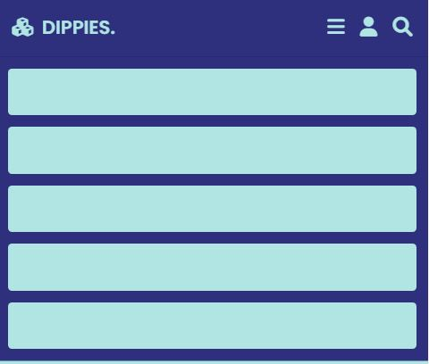

* **Script2.js**

let slides = document.querySelectorAll('.home .slides-container .slide');

let index = 0;

function next(){

    slides[index].classList.remove('active');

    index = (index + 1) % slides.length;

    slides[index].classList.add('active');

}

function prev(){

    slides[index].classList.remove('active');

    index = (index - 1 + slides.length) % slides.length;

    slides[index].classList.add('active');

}

var swiper = new Swiper('.roadmap-slider', {

    spaceBetween: 20,

    centeredSlides: true,

    autoplay: {

        delay:7500,

        disableOnInteraction: false,

    },

    loop:true,

    breakpoints:{

        0: {

            slidesPerView: 1,

        },

        640: {

            slidesPerView: 2,

        },

        768: {

            slidesPerView: 2,

        },

        1024: {

            slidesPerView: 3,

        },

    },

});

* **Script3.js**

'use strict';

// element toggle function

const elementToggleFunc = function (elem) { elem.classList.toggle("active"); }

// sidebar variables

const sidebar = document.querySelector("[data-sidebar]");

const sidebarBtn = document.querySelector("[data-sidebar-btn]");

// sidebar toggle functionality for mobile

sidebarBtn.addEventListener("click", function () { elementToggleFunc(sidebar); });

// testimonials variables

const testimonialsItem = document.querySelectorAll("[data-testimonials-item]");

const modalContainer = document.querySelector("[data-modal-container]");

const modalCloseBtn = document.querySelector("[data-modal-close-btn]");

const overlay = document.querySelector("[data-overlay]");

// modal variable

const modalImg = document.querySelector("[data-modal-img]");

const modalTitle = document.querySelector("[data-modal-title]");

const modalText = document.querySelector("[data-modal-text]");

// modal toggle function

const testimonialsModalFunc = function () {

  modalContainer.classList.toggle("active");

  overlay.classList.toggle("active");

}

// add click event to all modal items

for (let i = 0; i < testimonialsItem.length; i++) {

  testimonialsItem[i].addEventListener("click", function () {

    modalImg.src = this.querySelector("[data-testimonials-avatar]").src;

    modalImg.alt = this.querySelector("[data-testimonials-avatar]").alt;

    modalTitle.innerHTML = this.querySelector("[data-testimonials-title]").innerHTML;

    modalText.innerHTML = this.querySelector("[data-testimonials-text]").innerHTML;

    testimonialsModalFunc();

  });

}

// add click event to modal close button

modalCloseBtn.addEventListener("click", testimonialsModalFunc);

overlay.addEventListener("click", testimonialsModalFunc);

// custom select variables

const select = document.querySelector("[data-select]");

const selectItems = document.querySelectorAll("[data-select-item]");

const selectValue = document.querySelector("[data-selecct-value]");

const filterBtn = document.querySelectorAll("[data-filter-btn]");

select.addEventListener("click", function () { elementToggleFunc(this); });

// add event in all select items

for (let i = 0; i < selectItems.length; i++) {

  selectItems[i].addEventListener("click", function () {

    let selectedValue = this.innerText.toLowerCase();

    selectValue.innerText = this.innerText;

    elementToggleFunc(select);

    filterFunc(selectedValue);

  });

}

// filter variables

const filterItems = document.querySelectorAll("[data-filter-item]");

const filterFunc = function (selectedValue) {

  for (let i = 0; i < filterItems.length; i++) {

    if (selectedValue === "all") {

      filterItems[i].classList.add("active");

    } else if (selectedValue === filterItems[i].dataset.category) {

      filterItems[i].classList.add("active");

    } else {

      filterItems[i].classList.remove("active");

    }

  }

}

// add event in all filter button items for large screen

let lastClickedBtn = filterBtn[0];

for (let i = 0; i < filterBtn.length; i++) {

  filterBtn[i].addEventListener("click", function () {

    let selectedValue = this.innerText.toLowerCase();

    selectValue.innerText = this.innerText;

    filterFunc(selectedValue);

    lastClickedBtn.classList.remove("active");

    this.classList.add("active");

    lastClickedBtn = this;

  });

}

// contact form variables

const form = document.querySelector("[data-form]");

const formInputs = document.querySelectorAll("[data-form-input]");

const formBtn = document.querySelector("[data-form-btn]");

// add event to all form input field

for (let i = 0; i < formInputs.length; i++) {

  formInputs[i].addEventListener("input", function () {

    // check form validation

    if (form.checkValidity()) {

      formBtn.removeAttribute("disabled");

    } else {

      formBtn.setAttribute("disabled", "");

    }

  });

}

// page navigation variables

const navigationLinks = document.querySelectorAll("[data-nav-link]");

const pages = document.querySelectorAll("[data-page]");

// add event to all nav link

for (let i = 0; i < navigationLinks.length; i++) {

  navigationLinks[i].addEventListener("click", function () {

    for (let i = 0; i < pages.length; i++) {

      if (this.innerHTML.toLowerCase() === pages[i].dataset.page) {

        pages[i].classList.add("active");

        navigationLinks[i].classList.add("active");

        window.scrollTo(0, 0);

      } else {

        pages[i].classList.remove("active");

        navigationLinks[i].classList.remove("active");

      }

    }

  });

}

**Source code penggunaan Gambar, Video, dan Audio**

* **Penggunaan gambar di index.html**
* **Bagian home**

<section class="home" id="home">

    <div class="slides-container">

        <div class="slide active">

            <div class="content">

                <div class="slideimg">

                    <img decoding="async" src="img/main.png">

                </div>

* **Screenshoot bagian home**
* **Special followers**

<section class="banner-container">

    <div class="banner">

        <img decoding="async" src="img/discount.jpg">

        <div class="content">

            <span>special followers</span>

            <h3>upto 50% off</h3>

            <a href="https://wa.me/c/6288902028471" class="btn">check out</a>

        </div>

    </div>

</section>

* 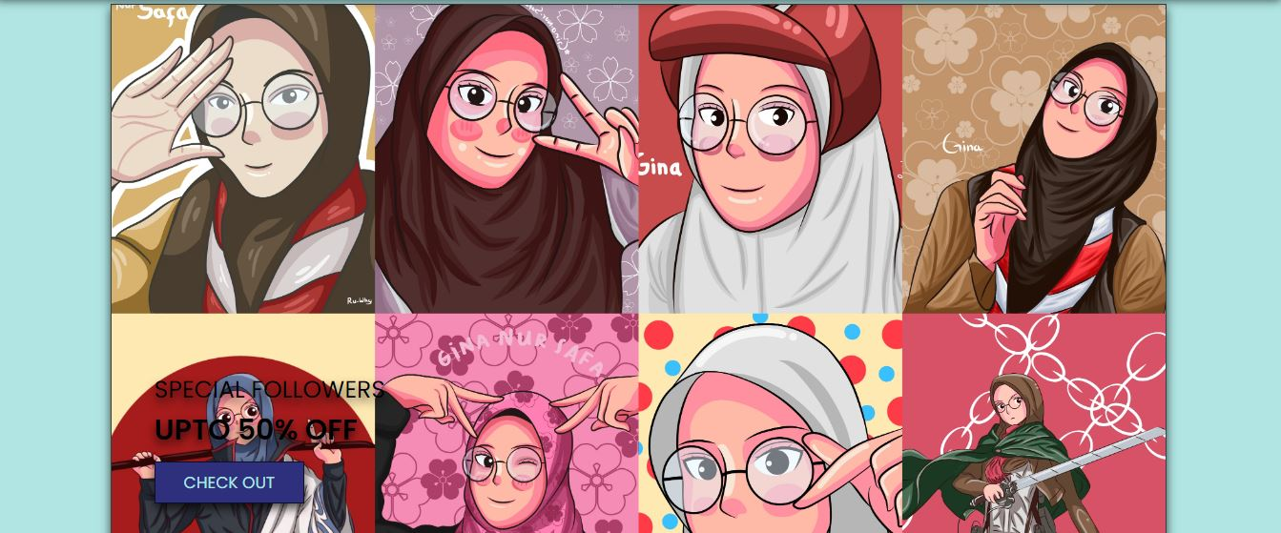**Screenshoot special followes**
* **Elemen di ourtype**

<div class="box-container">

        <div class="box">

            <div class="icons">

                <a href="#" class="fas fa-heart"></a>

                <a href="#" class="fas fa-eye"></a>

            </div>

            <div class="img">

                <img decoding="async" src="img/katalog1.png">

            </div>

 <div class="box">

            <div class="icons">

                <a href="#" class="fas fa-heart"></a>

                <a href="#" class="fas fa-eye"></a>

            </div>

            <div class="img">

                <img decoding="async" src="img/katalog2.png">

            </div>

 <div class="box">

            <div class="icons">

                <a href="#" class="fas fa-heart"></a>

                <a href="#" class="fas fa-eye"></a>

            </div>

            <div class="img">

                <img decoding="async" src="img/katalog3.png">

            </div>

 <div class="box">

            <div class="icons">

                <a href="#" class="fas fa-heart"></a>

                <a href="#" class="fas fa-eye"></a>

            </div>

            <div class="img">

                <img decoding="async" src="img/katalog4.png">

            </div>

<div class="box">

            <div class="icons">

                <a href="#" class="fas fa-heart"></a>

                <a href="#" class="fas fa-eye"></a>

            </div>

            <div class="img">

                <img decoding="async" src="img/katalog6.png">

            </div>

        <div class="box">

            <div class="icons">

                <a href="#" class="fas fa-heart"></a>

                <a href="#" class="fas fa-eye"></a>

            </div>

            <div class="img">

                <img decoding="async" src="img/katalog7.png">

            </div>

<div class="box">

            <div class="icons">

                <a href="#" class="fas fa-heart"></a>

                <a href="#" class="fas fa-eye"></a>

            </div>

            <div class="img">

                <img decoding="async" src="img/katalog8.png">

            </div>

* **Screenshoot elemen ourtype**

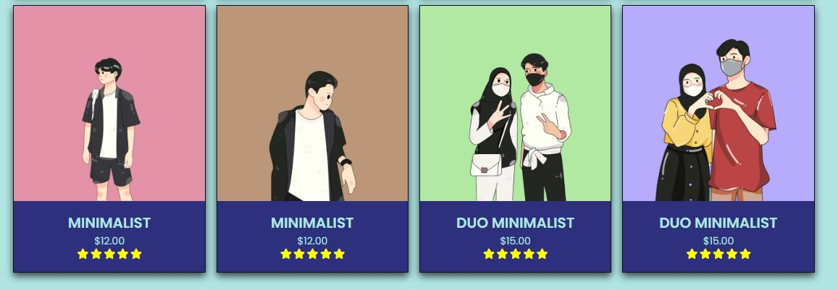

* **Profil di testimoni**

<section class="roadmap" id="roadmap">

    <div class="swiper mySwiper roadmap-slider">

        <div class="swiper-wrapper wrapper">

            <div class="swiper-slide slide">

                <i class="fas fa-quote-right"></i>

                <div class="user">

                    <img decoding="async" src="img/view1.png">

                    <div class="user-info">

<div class="swiper-slide slide">

<i class="fas fa-quote-right"></i>

<div class="user">

<img decoding="async" src="img/view2.png">

<div class="user-info"> <div class="swiper-slide slide">

<i class="fas fa-quote-right"></i>

<div class="user">

<img decoding="async" src="img/view3.png">

<div class="user-info">

* 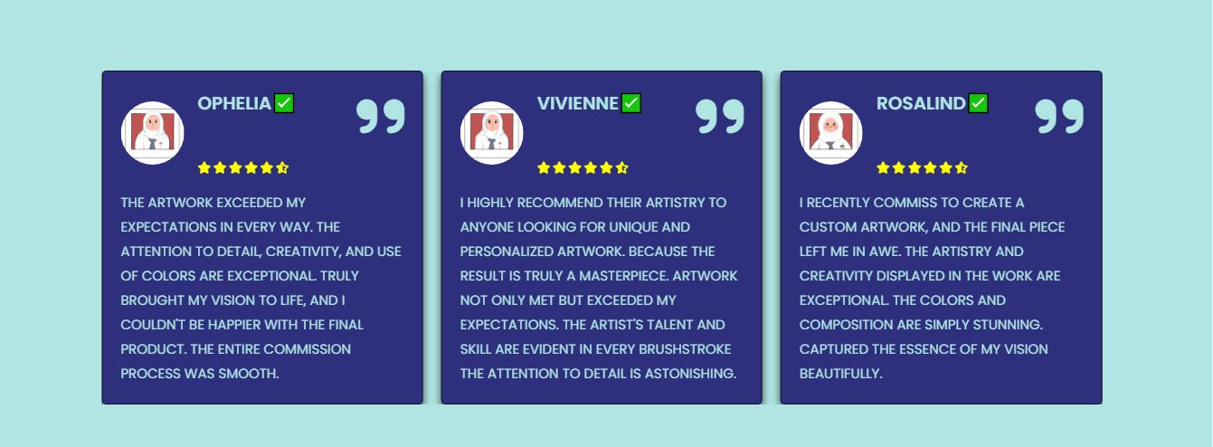**Screenshoot elemen gallery**
* **Gambar di index2.html**

<aside class="sidebar" data-sidebar>

        <div class="sidebar-info">

          <figure class="avatar-box">

            <img

              src="./img/profile.jpg"

              alt="Gina Nur Safa"

              width="80"

* **Screenshoot avatar di index2.html**



* **Icon di artwork**

 <ul class="service-list">

              <li class="service-item">

                <div class="service-icon-box">

                  <img

                    src="img/artwork2.png"

                    alt="design icon"

                    width="70"

<li class="service-item">

                <div class="service-icon-box">

                  <img

                    src="img/artwork1.png"

                    alt="camera icon"

                    width="70"

* **Screenshoot icon di index2.html**



1. **Tuliskan dan jelaskan (berikan analisis) mengenai perbedaan dan kesulitan pembuatan website dengan menggunakan Hard Coding (Ngoding sendiri) atau dengan menggunakan template. (Berikan analisis minimal 2 paragraf dengan 1 paragraf minimal menggunakan 5 kalimat)**

* **Perbedaan hardcoding dan template**

Ketika saya melakukan hard coding, saya dapat menyesuaikan tampilan website semau dan sesuai dengan selera saya. Dimulai dari warna sampai ke layout, begitu pula dengan pengerjaannya yang cukup lama karena banyak terjadi kesalahan yang menyebabkan tampilan yang saya inginkan tidak terbaca, alhasil dilakukan pengecekan yang lumayan lama

Sedangkan template justru pengerjaannya akan lebih cepat, karena hanya copy paste saja namun hasilnya relative sama dan monoton

* **Kesulitan**

1. **Memaksimalkan responsive**
2. **Memasukkan ke github/online**
3. **Pengulangan coding yang seringkali tidak terbaca**